**MID TERM PROJECT REPORT**

**AZAM KHAN & M.ZUBAIR**

APRIORI ALGORITHM

* A Data Mining Algorithm
* Frequent item set mining and association rule learning
* Creates Item permutations and then computes confidence given a minimum support

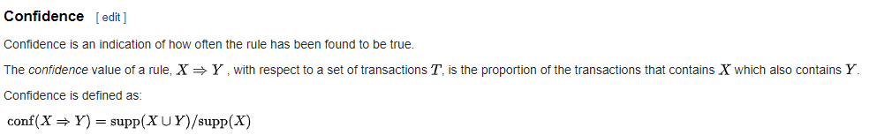



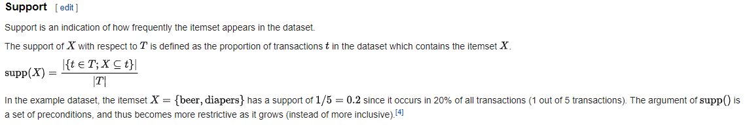

PARALLELIZATION APPROACH

* Instead of permutations create combinations
* When the combination set is loaded shuffle and compute all possible sets
* Use Index table instead of counting over and over again

WORKING EXPLANATION

* Load each combination and rows of each item to filter items according to minimum support
* Then compute Confidence , with data already loaded in registers
* This algorithm reduces numbers of seeks to global memory

